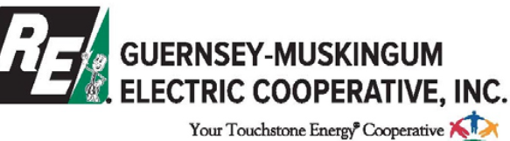

2022 Washington Youth Tour Rules

- The contest is only open to current sophomores and juniors.

- Applicant’s parents/guardians must be Guernsey-Muskingum Electric Cooperative members at the time of the youth tour.

- Members of the immediate families and persons residing in the households of cooperative directors, managers and employees are not eligible to participate in the competition

- Applications must be received at the cooperative office by the application deadline – Friday, March 4, 2022.

- Applicants will be interviewed and given a cooperative knowledge test on Wednesday, March 16, 2022.

- Applicants must be available for the entire tour from June 18 – 24, 2022. A portion or the full amount of the trip may be charged if the student withdraws after April 9, 2022.

